**CMSC 411.05 Homework Assignment 4 Due: Oct 17, 2:29 pm**

**Question 1** (10 points)

Assume we have this 1-bit ALU. What would be the “Result” if

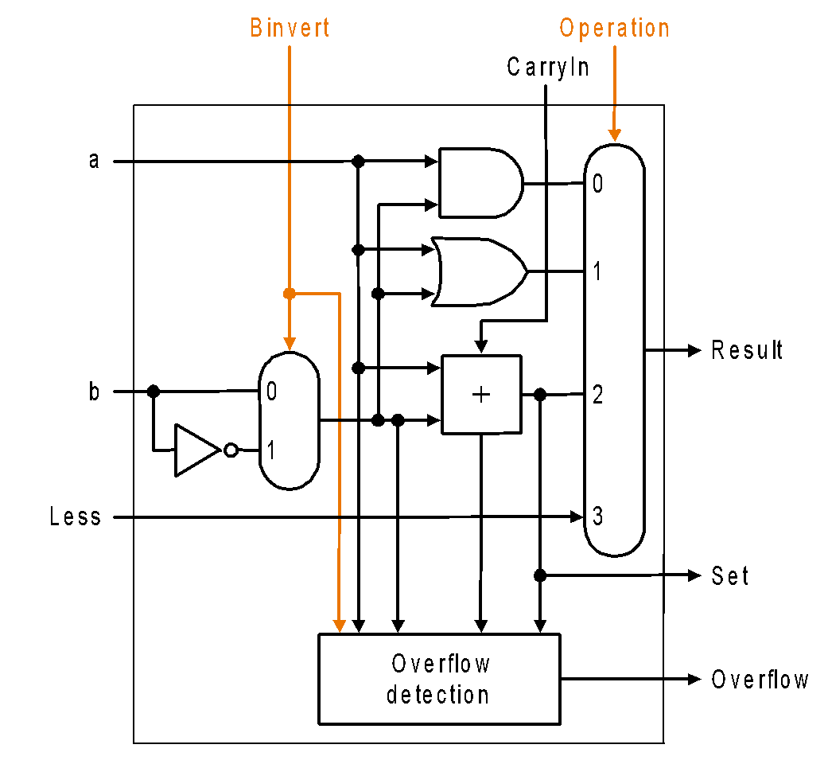

| a | b | Operation | CarryIn | Binvert | Result |
| --- | --- | --- | --- | --- | --- |
| 1 | 0 | 0 | 1 | 0 |  |
| 1 | 1 | 1 | 0 | 1 |  |
| 1 | 1 | 2 | 0 | 0 |  |
| 1 | 1 | 2 | 1 | 1 |  |
| 1 | 0 | 3 | 0 | 1 |  |

**Question 2 (10 points)**

1. Please take a look at the figure below and explain why there is an “Or” followed by an inverter on the right side of our ALU. For what kind of instruction do we need these components?
2. Assume a and b are 32-bits and we want to set the output to 1 if a is less than b. Please explain how MIPS can execute this “slt” instruction.

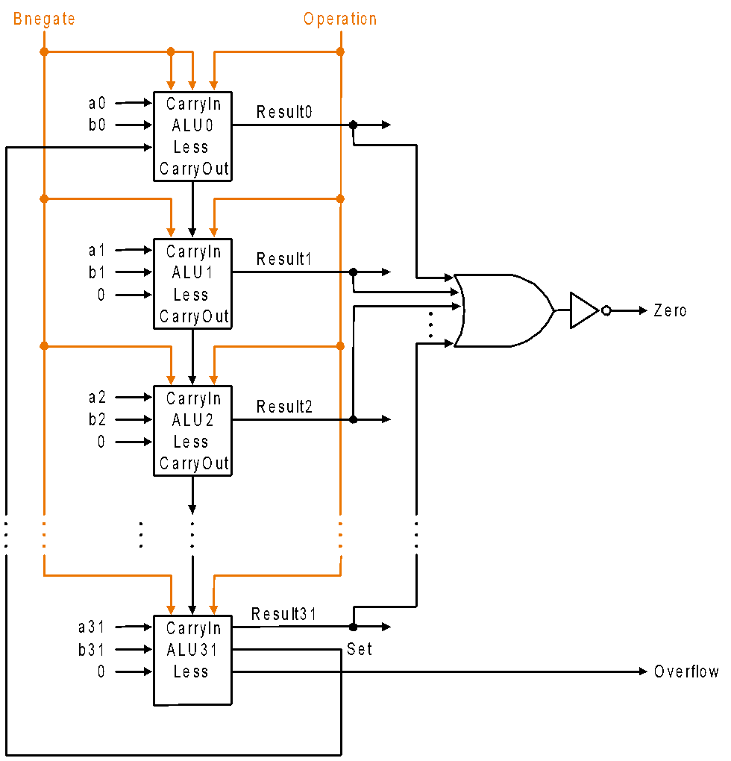

**Question 3 (10 points)**

Assume we would like to multiply two 5-bit numbers. Use the multiplier design-1 from Lecture 11 and fill out the following table to compute 14 x 12 (unsigned).

| Iteration | Step | Multiplier | Multiplicand | Product |
| --- | --- | --- | --- | --- |
| 0 |  |  |  |  |
| 1 |  |  |  |  |
| 2 |  |  |  |  |
| 3 |  |  |  |  |
| 4 |  |  |  |  |
| 5 |  |  |  |  |

**Question 4 (10 points)**

Assume we would like to multiply two 5-bit numbers. Use the multiplier design-2 from Lecture 11 and fill out the following table to compute 14 x 12 (unsigned).

| Iteration | Step | Multiplier | Multiplicand | Product |
| --- | --- | --- | --- | --- |
| 0 |  |  |  |  |
| 1 |  |  |  |  |
| 2 |  |  |  |  |
| 3 |  |  |  |  |
| 4 |  |  |  |  |
| 5 |  |  |  |  |

**Question 5 (10 points)**

Assume we would like to multiply two 5-bit numbers. Use the multiplier design-3 from Lecture 11 and fill out the following table to compute 14 x 12 (unsigned).

| Iteration | Step | Multiplicand | Product |
| --- | --- | --- | --- |
| 0 |  |  |  |
| 1 |  |  |  |
| 2 |  |  |  |
| 3 |  |  |  |
| 4 |  |  |  |
| 5 |  |  |  |

**Question 6 (10 points)**

Assume we would like to multiply two 5-bit numbers. Use Booth’s algorithm from Lecture 11 and fill out the following table to compute 14 x (-12).

| Iteration | Step | Multiplicand | Product |
| --- | --- | --- | --- |
| 0 |  |  |  |
| 1 |  |  |  |
| 2 |  |  |  |
| 3 |  |  |  |
| 4 |  |  |  |
| 5 |  |  |  |